Junior Maths Extension Course

Probability

Contents
The basics 3
Sample space 4
Multiple events 5
Probability of either of two events occurring 5
Probability of both of two events occurring 5
Combining the two 6
Probability trees 7
Starter questions 8
Questions 9
Starter problem 11
Answer 11
Relative (experimental) frequency 12
Questions 12
Answers 13
Flipping coins experiment 14
Theoretical approach 14
Questions 15
The Monty Hall Problem 16
Experimental probability 16
Theoretical probability 16
Starter – Christmas crackers 17
Answer 18
Buffon’s Needle 19
Probability with continuous values 20
Questions 22
Answers 23
Probability questions 25

The basics
Probability is the likelihood that a something will occur.
It is measured between 0 (can not occur) to 1 (is certain to occur). Sometimes you will see it as 0 – 100%.
If there is a probability of 0.5, then it is equally likely to occur or not occur.
Anything that has a probability less than 0.5 is unlikely to occur, while above 0.5 is likely to occur.
0.5
1
0
Likely
Unlikely
Equally likely
Certain
Impossible

Sample space
In probability, sample space is the set of all possible outcomes.

For example, when flipping a coin, the sample space is { Head, Tail }

When can find the probability of an event by counting up how many ways it could occur and dividing it by the number of outcomes in the sample space.
For example, the probability of getting a prime number when we roll a dice can be found by:
- Writing out the sample space: {1, 2, 3, 4, 5, 6}
- Counting how many outcomes there are: 6
- Counting how many ways there are to get a prime number: 3 (2, 3, and 5)
- Dividing: 3/6 = 1/2
- Therefore, the probability of getting a prime is 1/2

Multiple events

Probability of either of two events occurring
When we calculate the probability of either one event or another occurring, we add the probabilities.
For example, find the probability of flipping two coins and getting either two heads or two tails.
From the sample space we can see their respective probabilities:
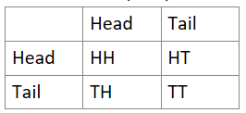
There are four possible outcomes, and only one way to get two heads (HH), and only one way to get two tails (TT).
By circling each outcome that meets the question, we get:
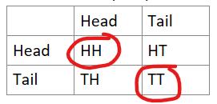
You can see that the probability of the red circles occurring is 2/4, or 1/2.
This is the same as adding the probabilities of each together:
P(HH) = 1/4
P(TT) = 1/4
P(HH or TT) = $\frac{1}{4}+\frac{1}{4}=\frac{1}{2}$

Probability of both of two events occurring
When calculating the probability of multiple events occurring, we multiply the probabilities.
For example, find the probability of rolling two 1s in a row on a 6-sided dice.
P(1) = 1/6
P(1 and then another 1) = 1/6 x 1/6 = 1/36
We can also see this from a sample space table:
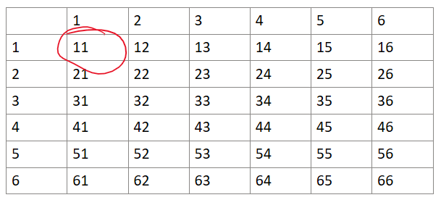
There are 36 possible outcomes when we roll a die twice, but only one of them will result in two 1s being rolled in a row.

Combining the two
We can combine these two approaches to solve problems like: "What is the probability of rolling a 1 and a 6 when I roll two dice?"
In this case, we could roll the 1 first and then a 6, or get the 6 first and then the 1.
P(1 then a 6) = $\frac{1}{6}×\frac{1}{6}=\frac{1}{36}$
P(6 then a 1) = $\frac{1}{6}×\frac{1}{6}=\frac{1}{36}$
Since there are multiple ways for this to occur, we then add the probabilities:
$$\frac{1}{36}+\frac{1}{36}=\frac{2}{36}=\frac{1}{18}$$

We can also see this from our sample space:
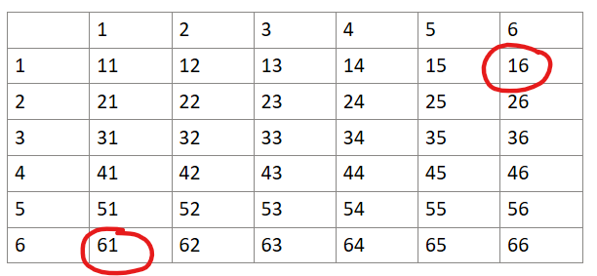

Probability trees
We can use probability trees to visualise a series of events, and then use them to calculate the probability of a sequence of particular events occurring.
For example, If we toss three coins, we can visualise all the possible outcomes in a tree:
(On the far right you can see the sample space as well.)
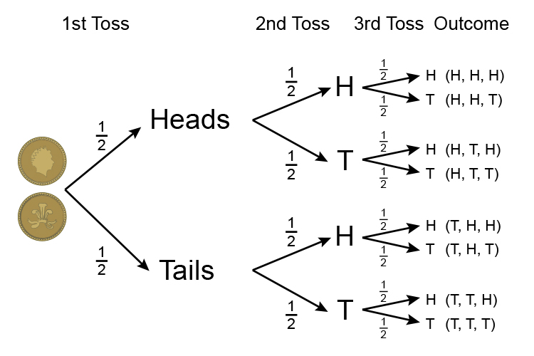
The branches of probability trees will not always have the same probabilities.
For example, below is a tree where we have two events occurring: a dice is rolled and then a coin is flipped:
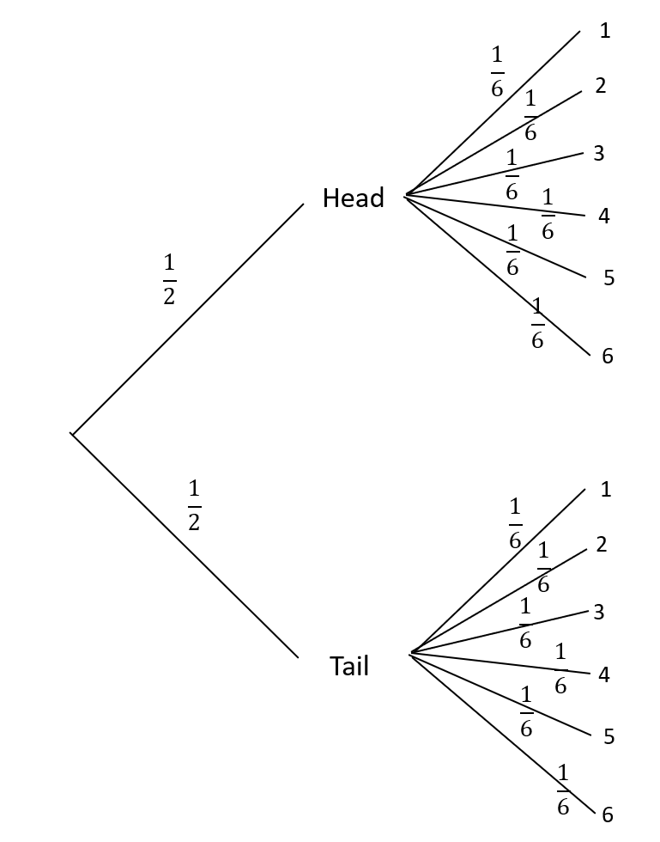
To find the probability of a combination of results happening, we simply follow the branches along each result and multiply the probabilities as we go.
For example, the probability of tossing a head and rolling a 1 is $\frac{1}{2}×\frac{1}{6}=\frac{1}{12}$
In the case where we want to know the probability of multiple combinations of results happening we work out the probability of each result, then add them all up.
For example, the probability of tossing a head and getting a 5 or 6:
P(Head and 5) = $\frac{1}{2}×\frac{1}{6}=\frac{1}{12}$
P(Head and 6) = $\frac{1}{2}×\frac{1}{6}=\frac{1}{12}$
Therefore, P(Head and 5 or 6) = $\frac{1}{12}+\frac{1}{12}=\frac{1}{6}$

Starter questions
Draw a probability tree for the scenarios below and use it to answer the questions for each scenario.
Scenario 1
A bag has 5 red counters, 3 blue counters and 2 green counters in it.
One counter is drawn from the bag, the colour is recorded and the counter is returned to the bag. A second counter is drawn and the colour is recorded.
- What is the probability of getting 2 red counters?
- What is the probability of getting 2 counters that have the same colour?
- What is the probability of only getting one blue counter?

Scenario 2
Same setup with the bag and counters.
This time, when the first counter is drawn and the colour is recorded, the counter is not replaced. A second counter is then drawn from the bag and the colour is recorded.
- What is the probability of getting 2 red counters?
- What is the probability of getting 2 counters that have the same colour?
- What is the probability of only getting one blue counter?

Questions
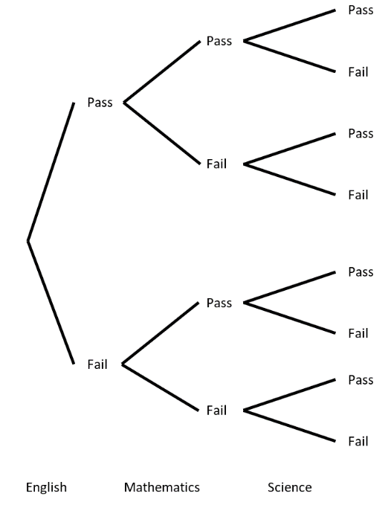
Question 1
A student is about to sit her examinations in English, Mathematics and Science. The probability that she passes English is 0.9, Mathematics 0.8 and Science 0.6.
Use these probabilities to complete the diagram.

Using this diagram find the probability that:
- she fails all three examinations
- she passes all three examinations
- she passes exactly two examinations

Question 2
A large online survey was carried out, asking 2500 New Zealanders for their views about water use.
87% were concerned about water shortages, and:
- 80% usually try to save water (such as taking shorter showers).
- 18% only try to save water when restrictions are in place.
- 2% never try to save water.
Of those not concerned about water shortages:
- ½ usually try to save water.
- ¼ only try to save water when restrictions are in place.
- The rest never try to save water.
Use this information to complete the probability tree below.
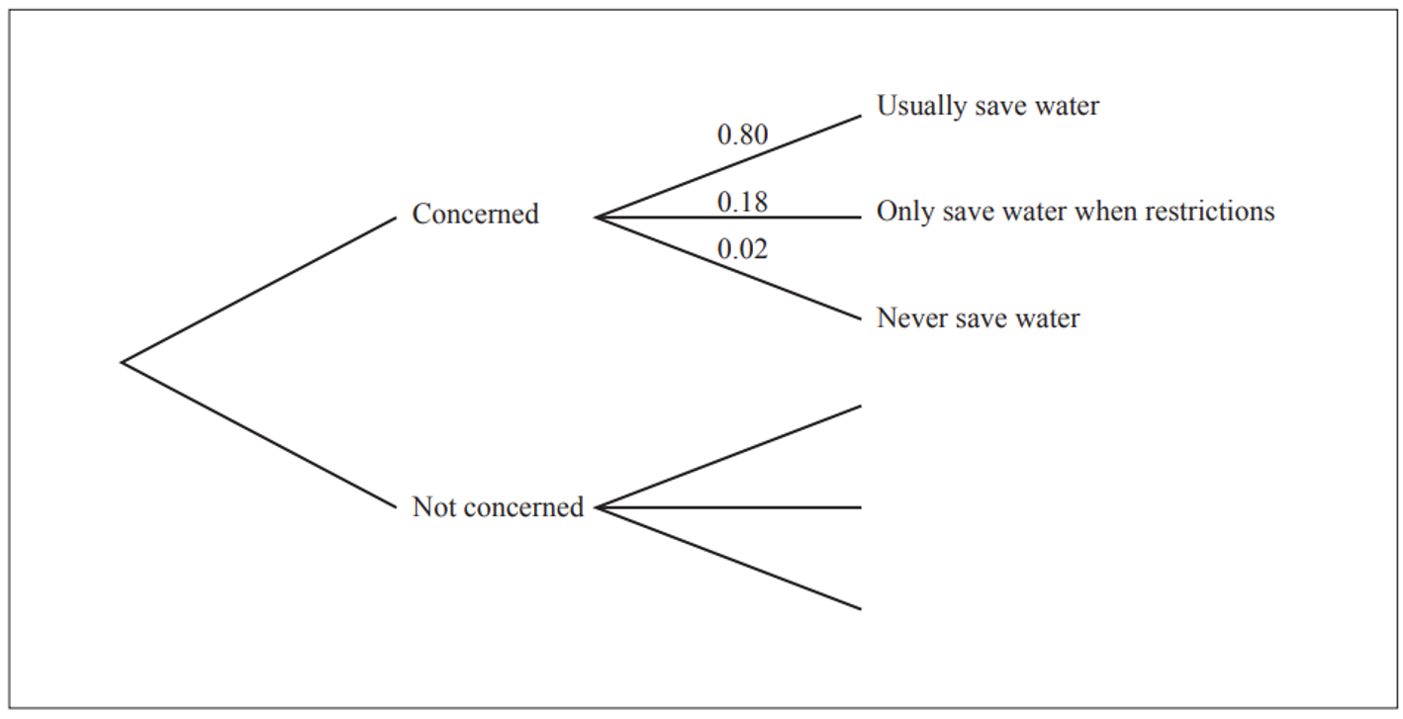
What is the probability that a respondent chosen at random is concerned about water shortages and usually saves water?
Of 2500 survey respondents, how many said they “only save water when restrictions are in place”?

Question 3
A secondary school teacher wondered if young people’s views would be similar to those seen in the online survey described in part (a). She surveyed 200 students from years 9 to 13 at two local high schools.
She found:
- 70% of students were concerned about climate change.
- Of those who were concerned about climate change, 85% were also concerned about water shortages.
- 55% of those who were not concerned about climate change were concerned about water shortages.
Draw a probability tree of this situation and use it to find the probability that a student chosen at random is concerned about water shortages.

Question 4
The use of plant-based “milks” in New Zealand has become much more popular in recent years. Cafes also now offer their customers a number of alternative milk options such as soy, almond, or coconut milk.
- Jungwoo owns a café and has collected data of his coffee sales over the last few weeks to find out how much he should stock alternative milk products.
  - 40% of his coffee sales were to younger customers.
  - One quarter of younger customers requested an alternative milk type.
  - 80% of older customers ordered a coffee with cow’s milk.
  - Of the younger customers who ordered a coffee with alternative ilk, 15% ordered soy milk.
  - Half of the older customers who ordered a coffee with alternative milk, ordered soy milk.
- Find the probability that a customer in this café is younger and orders a coffee with cow’s milk.
- Find the probability that a randomly chosen customer orders coffee with soy milk.

Question 5
Two students, Caitlin and Carly, are playing a game that uses ten different numbered cards lying face down on a table. The faces of the cards are labeled with one of the numbers from 1 to 10 (each card has a different number). If Caitlin and Carly each turn over a different card, what is the probability that the sum of the two cards is even?

Question 6
Five counterfeit coins are mixed with nine authentic coins. If two coins are drawn at random, find the probability that one coin is authentic and one is counterfeit.

Starter problem
Four normal six-sided dice are thrown. What is the probability that the product of the numbers is equal to 36?

Answer
There are 6 x 6 x 6 x 6 = 1296 possibilities.
Considering the possible results that would multiply to 36, we get:
1 1 6 6
2 2 3 3
1 2 3 6
1 3 3 4
For each, we can rearrange the numbers in a different order. For example, 1 1 6 6 can be rearranged to 1 6 1 6, 1 6 6 1, 6 1 6 1, 6 1 1 6 and 6 6 1 1. Therefore, there are 6 different ways to rearrange those numbers.
Similarly, there are 6 ways to rearrange 2 2 3 3.
There are 12 ways to rearrange 1 3 3 4, and 24 ways to rearrange 1 2 3 6.
Therefore, there are 6 + 6 + 12 + 24 = 48 ways to get a product of 36.
This means the probability is $\frac{48}{1296}=\frac{1}{27}$

Relative (experimental) frequency
In some cases, we cannot calculate theoretical probabilities (such as the probability that a car passing by chosen at random is red), so we perform experiments to gather data and then use this to estimate the probability of an event occurring.
As with using sample space, the probability of an event occurring is $\frac{\# favourable outcomes}{total trials}$

Questions
Question 1
New Zealand is well known for its café culture, and the availability of coffee has increased significantly over the last 20 years. However, there is growing concern that teenagers are consuming more caffeine, with potential negative effects on sleep behaviours and performance at school.
A school was concerned about this issue and conducted an online, anonymous survey of 300 of its senior students. It asked if students drink coffee regularly (at least 3 times a week) and if they have any sleep-related issues. The results are summarised in the table below.
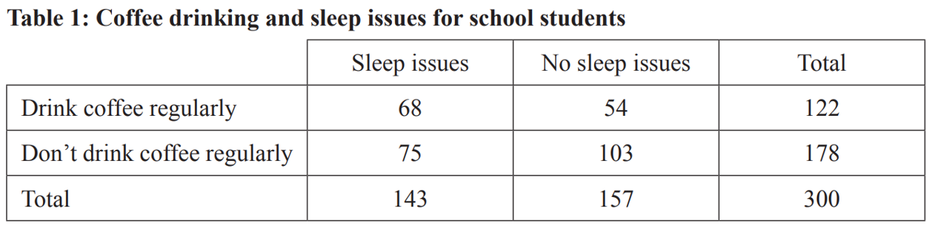
According to the results of this survey, what proportion of the senior students drink coffee regularly?
What is the probability that a randomly chosen student from this survey who has sleep issues also drinks coffee regularly?

Question 2
LAWA ( Land, Air, Water Aotearoa) conducted a survey and tested some New Zealand rivers in different land types to see if they were safe for swimming. The results from the survey are presented in the table below.
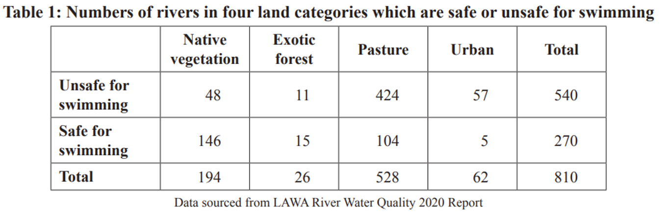
What is the probability that a randomly chosen river out of those tested is an urban river and is unsafe for swimming?
Is a river in native vegetation more likely to be safe for swimming than a river in an exotic forest area?

Answers

Flipping coins experiment
Ted and Erin play a game in which they take turns flipping a fair coin.
The first player to flip heads wins. If Erin goes first, what is the probability that she wins?

Step one:
Pair up with someone and take turns flipping a coin, playing until one of you wins by flipping a head.
Record who wins each time, the person going first or the person going second.
We need at least 20 trials from each pair.

Step two:
Collate the data from all pairs into a table.
Calculate the probability that the first person wins for each sample.
Sum all of the trial data and use it to calculate the overall probability that the first person wins.
Is the probability the same for all samples?
What does the probability appear to be?

Theoretical approach
In this case we can’t list a sample space as the game could (theoretically) continue forever. For that same reason, we can’t draw a probability tree either.
So, in this case we prepare a table showing the probability that each player wins in round one, round two, and so on, and look for a pattern.
 | Round 1 | Round 2
Erin | $$\frac{1}{2}$$ | P(Erin didn’t win R1) x P(Ted didn’t win R1) x P(Erin wins R2)  $$\frac{1}{2}×\frac{1}{2}×\frac{1}{2}$$
Ted | P(Erin didn’t win) x P(Ted wins)  $$\frac{1}{2}×\frac{1}{2}$$ | $$\frac{1}{2}×\frac{1}{2}×\frac{1}{2}×\frac{1}{2}$$

Notice that the probability that Ted wins in a given round is always going to be ½ times the probability that Erin wins.
From this we can form an equation: $T=\frac{1}{2}E$
Since we know that the probabilities must sum to 1, we get:
$$T+E=1 \\ \frac{1}{2}E+E=1 \\ \frac{3}{2}E=1 \\ E=\frac{2}{3}$$
Therefore, there is a 2/3 probability that Erin will win if she goes first.

Questions
What if the game was rolling a single dice? If the first person to roll a 6 wins, what is the probability that going first results in a win?

Calculate the probability of the first person winning a game where they take turns rolling two dice and the winner is the first person to roll a snake eyes (double 1s).

The Monty Hall Problem
Monty Hall hosted a game show where there were three doors.
Behind two doors were a bad prize, like a dead, rotting goat, while behind one of the doors was an expensive car.
You get to choose one door to open, but before it was opened, Monty Hall would open one of the other two doors, revealing a goat. He then asked if you wanted to change your selection.
What should you do?

Experimental probability
First we will do the experiment ourselves, gathering data to see what option has the best chance of winning the car.
Pair up with someone, taking 3 paper cups and a prize each. Perform 20 trials for each strategy (change or stay). Record your results in a table like this:
Stay |  | Change
Win | Lose | Win | Lose

After everyone has finished, collect the data and collate results. Which strategy appears to be best based on the trials?
Is the result the same for each sample?

Theoretical probability
Now we look at the theoretical probability to see if it matches our results.
Write out the sample space for this experiment. List all of the possible outcomes in this format:
Your pick | Prize door | Stay | Change
1 | 1 | Win | Lose

Based on the sample space, what is the theoretical probability of winning for each strategy? Does it make a difference whether you change or not?

Probability and the Monty Hall problem | Probability and combinatorics | Precalculus | Khan Academy - YouTube

Starter – Christmas crackers
Jack and Jill’s family, a family of eight people, sits down to a Christmas dinner. Before the meal, they do the traditional Christmas cracker pull. If each person pulls a cracker with the two people either side of them (as in the diagram below), what is the probability that every single person ‘wins’ a cracker pull and gets to wear a silly Christmas hat and win the prize inside the cracker?
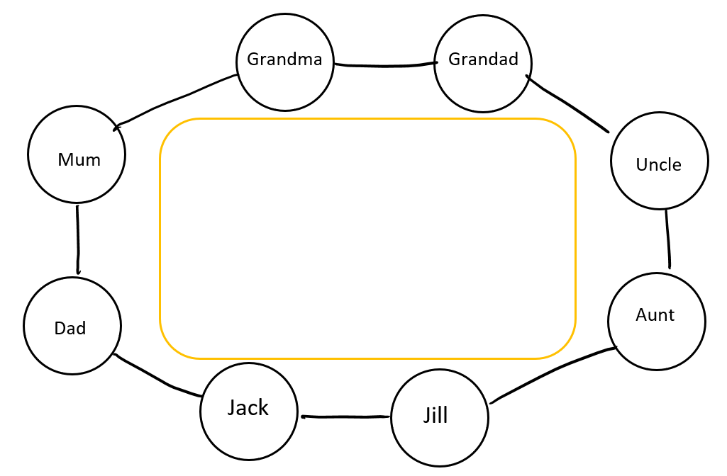

Answer
Consider a simpler example first, such as there only being two people.
In this case, each person wins if they both win the cracker they are holding in their left hand, or if they both win the cracker they holding in their right hand.
The probability of this will be $\frac{1}{2}×\frac{1}{2}+\frac{1}{2}×\frac{1}{2}=\frac{1}{2}$

Now, what about three people?
Again, the only way for everyone to win is if they all win the cracker in the same hand (left or right).
The probability of this will be $\left(\frac{1}{2}×\frac{1}{2}×\frac{1}{2}\right)+\left(\frac{1}{2}×\frac{1}{2}×\frac{1}{2}\right)=\frac{1}{4}$

This is another power of ½.
If we continued to expand on this, we could see that the answer will always be ${\left(\frac{1}{2}\right)}^{n-1}$, where n is the number of people at the table.
Therefore, the probability of all 8 people winning is ${\left(\frac{1}{2}\right)}^{7}=\frac{1}{128}$

Buffon’s Needle
Take a needle / toothpick of length n cm.
On a piece of paper, draw a series of parallel lines that are all n cm apart.
If you drop the needle / toothpick from a height above the paper, what is the probability that when it lands and settles it touches one of the lines?

Pair up and take a toothpick and lined piece of paper. Conduct at least 100 trials, recording each time whether the toothpick touched a line or did not touch a line.

Collect all of the results in and collate them. Do we get the same result for each sample? Why is this?
Calculate the probability based on summing all of the trial data.

Weirdly enough, this is actually $\frac{2}{π}$!

(2) How to get a Pi Out of needles? | Simulation | Buffon's Needle - YouTube

(2) Surprising π from probability! Buffon's needle problem - YouTube

Probability with continuous values
Sometimes it is impossible to count the total number of events because there are infinitely many possibilities. Some problems involve evaluating points on a line segment or in space, or particular values of a continuous variable such as time.
For example:
Lawrence parked his car in a parking lot at a randomly chosen time between 2:30 PM and 4:00 PM. Exactly half an hour later he drove his car out of the parking lot. What is the probability that he left the parking lot after 4:00 PM?
We can divide hours into minutes, minutes into seconds, and seconds into smaller and smaller fractions. There are an infinite number of times during which Lawrence could have driven away. We cannot count times to solve this problem!
Time is continuous, so we’ll have to think differently about this problem. Look at a line segment that represents the possible times Lawrence could drive away:
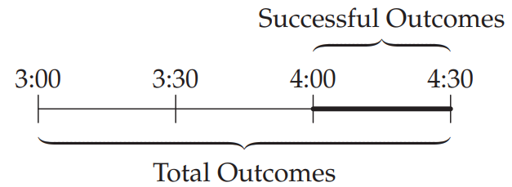
We can determine the probability that Lawrence drove away after 4:00 PM by comparing the length of the segment of successful outcomes to that of the total outcomes:
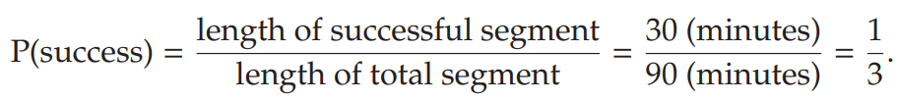
Now that we’ve seen one example of geometric probability, we can generalise the central idea:
When a probability calculation involves one or more continuous variables, we can determine the probability by comparing the sizes of the geometric regions:
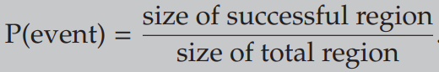
Sometimes the sizes we compare are lengths, sometimes they are areas, and sometimes they are volumes.
For example:
If $1≤x≤4$ and $2≤y≤6$, find the probability that $x+y≥5$
The problem is a little more complex because we have two distinct continuous variables. However, the concept is the same: we need to compare the successful region to the total region in order to determine the probability.
Let’s examine the graph of the total region in which the successful region is shaded:
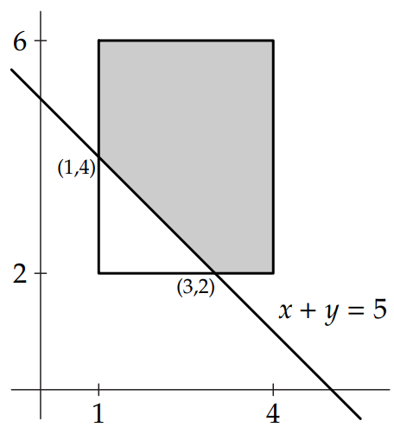
The regions we are comparing are areas. We determine the probability by comparing these areas:
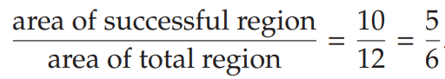
You might notice that in this case it is easier to compute the area of the unsuccessful region.
We can calculate that probability and subtract it from 1:
We call this technique complementary probability and it comes in handy quite often.

Questions
Question 1
What is the probability that a point anywhere within the shaded area on the axis below has x and y coordinates that add to more than 7?
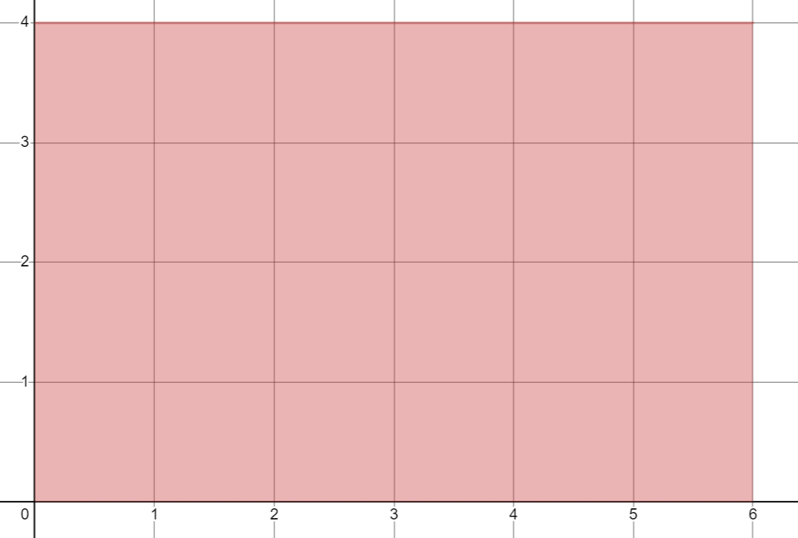

Question 2
If two real numbers between 0 and 5 are added together, what is the probability that their sum is greater than 8?

Question 3
For any two real numbers x and y, where $2≤x≤5$ and $3≤y≤8$, what is the probability that $x-y<1?$

Answers
Question 1
Adding the line $x+y=7$, we see that the area above this is what we are trying to find. We can easily find the coordinates for the corners of the triangle since we know they must add to 7, and we know y=4 across the top and x=6 on the right side.
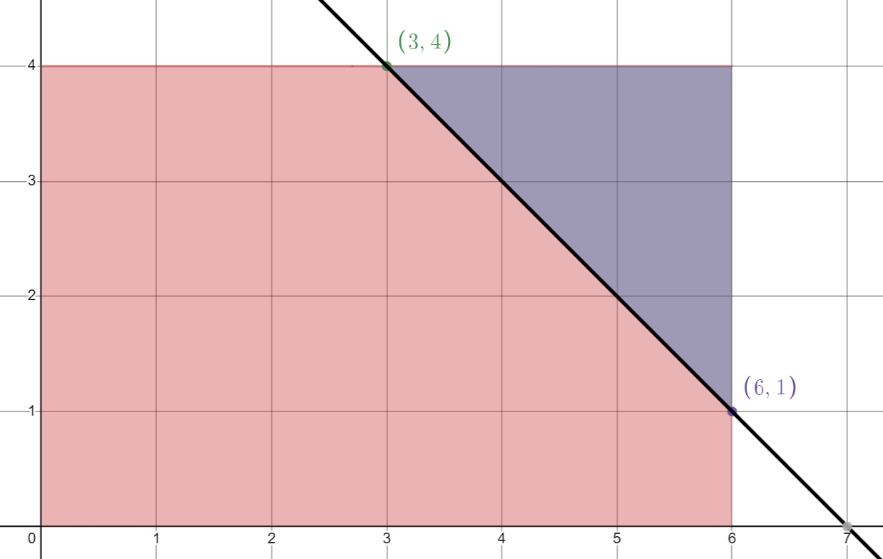
The triangle has a width and height of 3, therefore its area is $\frac{1}{2}×3×3=4.5$
The area of the rectangle holding all possibilities is $6×4=24$
Therefore, the probability of the coordinates adding to more than 7 is $\frac{4.5}{24}=\frac{9}{48}=\frac{3}{16}$

Question 2
Looking at it geometrically, we get:
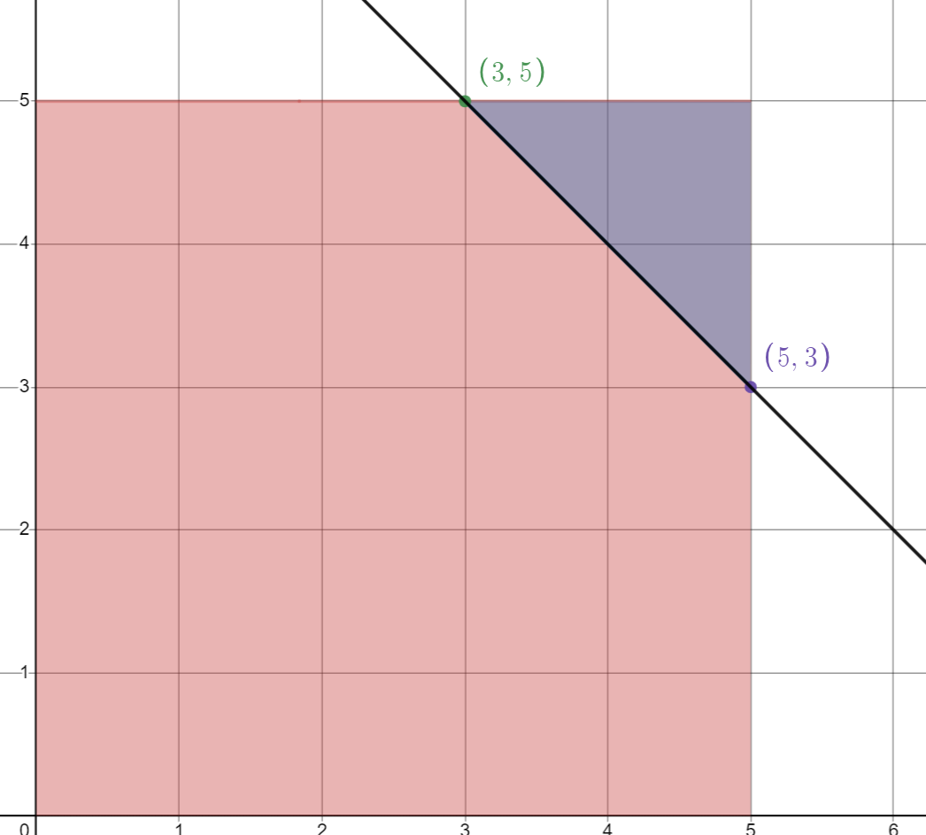
The triangle has area of $\frac{1}{2}×2×2=2$
The rectangle with all possibilities has area of 25.
Therefore, the probability the numbers sum to more than 8 is $\frac{2}{25}$

Question 3
For any two real numbers x and y, where $2≤x≤5$ and $3≤y≤8$, what is the probability that $x-y<1?$
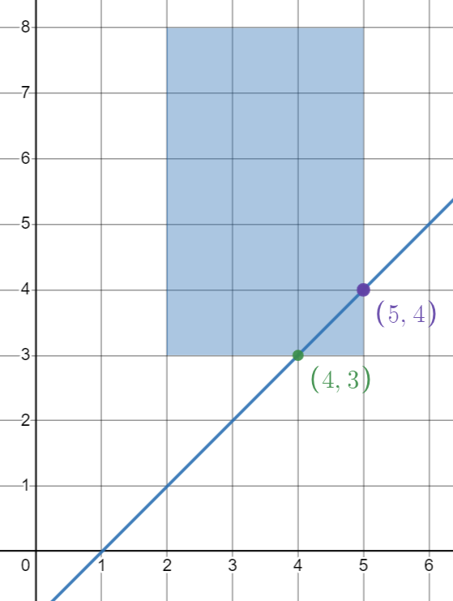
Area of triangle = $\frac{1}{2}×1×1=\frac{1}{2}$
Area of rectangle = $3×5=15$
Therefore, the probability that $x-y<1$ will be $\frac{0.5}{15}=\frac{1}{30}$

Probability questions
Question 1
Of the 12 marbles in a bag, exactly 3 are blue. If Sandor reaches into the bag and pulls out two marbles, what is the probability that exactly one of them is blue?

Question 2
Olga and Andrew play chess each day. The probability that Olga beats Andrew on any given day is twice the probability that Andrew beats Olga. The probability that Andrew beats Olga is three times the probability that the game ends in a draw (tie). What is the probability that any particular game between Olga and Andrew ends in a draw?

Question 3
A fair coin is flipped three times. What is the probability that at least one lands heads and at least one lands tails?

Question 4
An aircraft is equipped with three engines that operate independently. The probability of an engine failure is 0.01. What is the probability of a successful flight if only one engine is needed for the successful operation of the aircraft?

Question 5
Two real numbers x and y are randomly selected on a number line between 0 to 12. Find the probability that their sum is greater than 15.

Question 6
The surface of an 8 × 10 × 12 block is painted green after which the block is cut up into 960 smaller 1 × 1 × 1 cubes. If one of the smaller cubes is selected at random, what is the probability that it has green paint on at least one of its faces?

Question 7
Bender orders two robot painters to paint a 1000 meter long circular fence. One robot painter is ordered to paint a randomly selected 720 meter stretch of the fence while the other is ordered to paint a randomly selected 750 meter stretch of the fence. Find the probability that when the robot painters are done, the entire fence has been painted.

Question 8
A point (x, y) in the coordinate plane satisfies the inequalities −6 < x < 6 and −6 < y < 6, where x and y are real numbers. Find the probability that the point (x, y) is less than 4 units from the origin.

Question 9
In a game played with a fair cubical die with faces numbered 1 to 6, players take it in turns to throw the die.
The first player to throw the die choses one of the possible scores to be a “winning score”. If they get that score on their throw, they win and the game is over.
If their score does not come up, the die is given to the second player, who choses two of the possible scores to be “winning scores”. If they get one of those scores with their throw, they win and the game is over.
If neither of their scores comes up, the die is given to the next player, who choses three of the possible scores to be “winning scores”. If they get one of those scores with their throw, they win and the game is over.
The game continues in this way with one more “winning score” allowed for each successive throw.
(i) Jem and Tim play this game, taking it in turns to throw the die, with Jem going first. Who is more likely to win this game, Jem or Tim? Provide evidence to support your answer.
(ii) Sam comes to join Jem and Tim, so now the game is played by three people, still taking it in turns to throw. Which player will have the best chance of winning if they throw in the order Jem, Tim, Sam? Again, provide evidence!

Question 10
Eight students, named Alex, Baz, Bryn, Ed, Eliza, Erno, Nur and Tia sit in a row.
What is the probability that as you look along the row, there will be three students sitting next to each other so that taken in the order they are sitting, their initials spell “ANT”?
What is the probability that as you look along the row, there will be three students sitting next to each other so that taken in the order they are sitting, their initials spell “BEE”?
What is the probability that as you look along the row, you find both “ANT” and “BEE” spelt out by their initials?

Question 11
An ’unfair’ coin has a 2/3 probability of turning up heads. If this coin is tossed 50 times, what is the probability that the total number of heads is even?

Question 12
Two mathematicians take a morning coffee break each day. They arrive at the cafeteria independently, at random times between 9 AM and 10 AM, and stay for exactly m minutes. Find the value of m if the probability that either one arrives while the other is in the cafeteria is 40%.

Question 13
A fair coin is to be tossed ten times. Find the probability that heads never occur on consecutive tosses. (Source: AIME)

Question 14
6 apples and 4 bananas are shared between 5 children.
Each child gets two pieces of fruit, but apart from this, the fruit is handed out at random.
What is the probability that at least one child gets two bananas?

